## Question 1

#### 1. O1 to MUX6

ADD R0, R0, R0  
ADD R1, R1, R0  
ADD R1, R0, R1

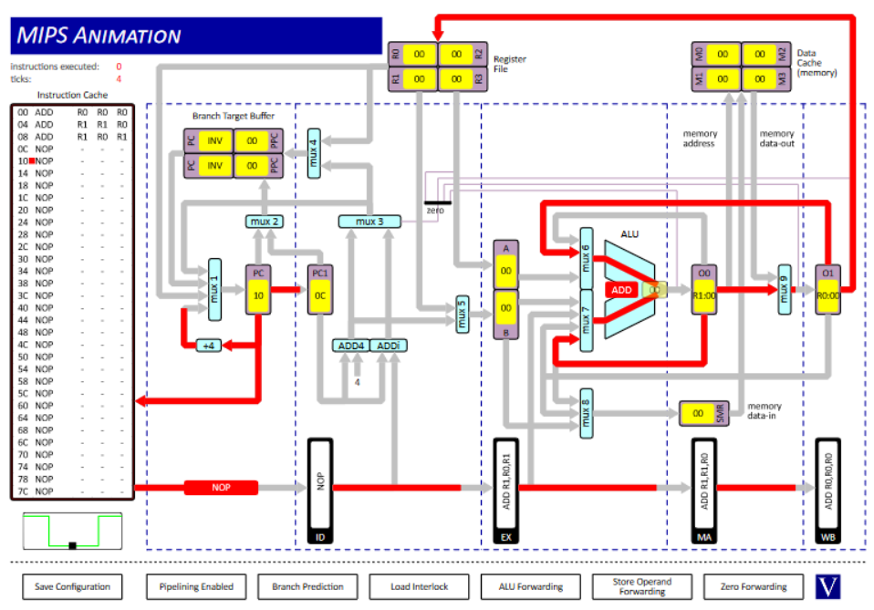

1-2

#### 2. O0 to MUX7 & O1 to MUX6

ADD R0, R0, R0  
ADD R1, R1, R0  
ADD R1, R0, R1



1-2

#### 3. O0 to MUX8

ST R0, R0, 0

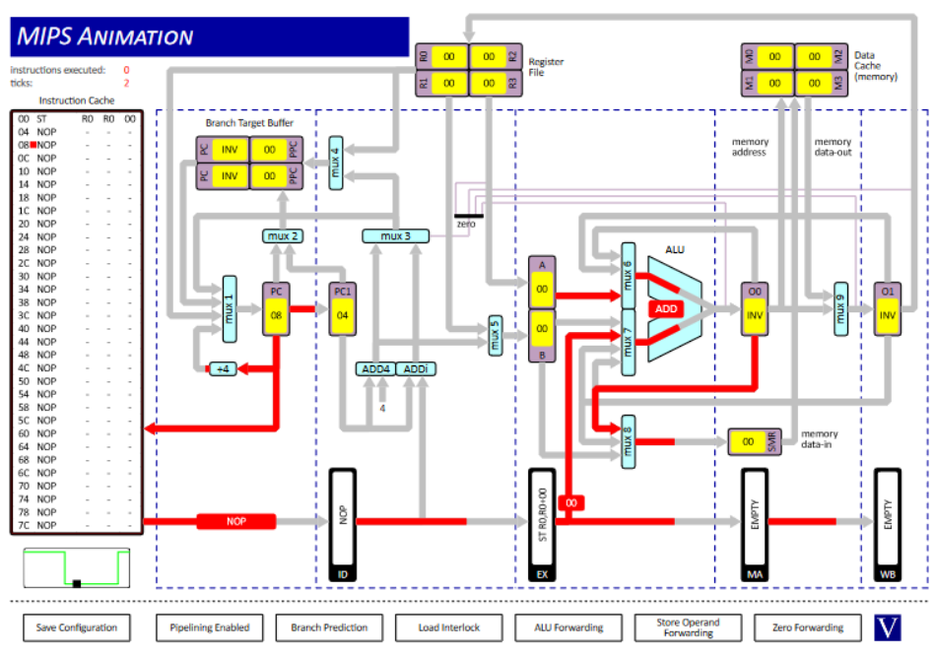

3-4

#### 4. EX to MUX7

ST R0, R0, 0



3-4

### 5. DC to MUX9

LD R0, R0, 0

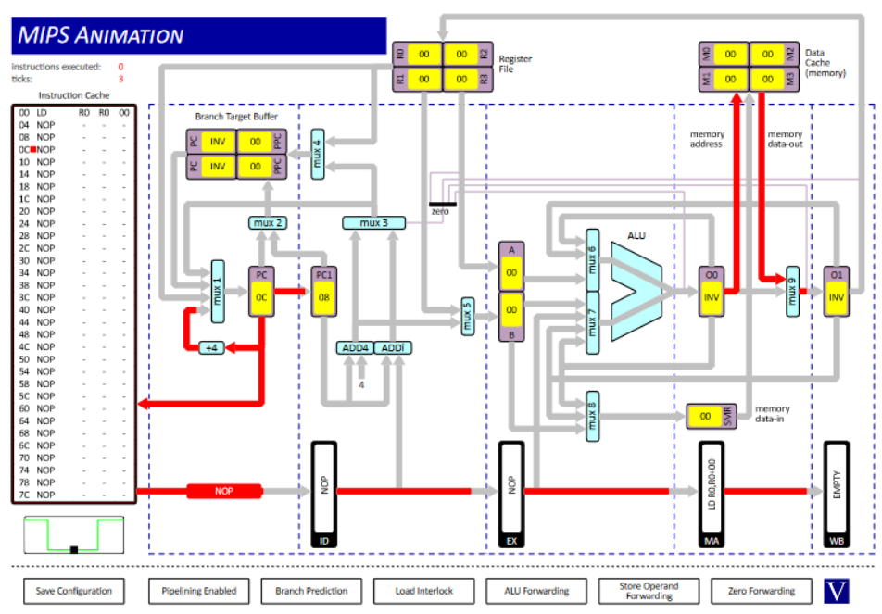

5

#### 6. O0 to ZD

ADD R0, R0, R0  
BEQZ R0, 0

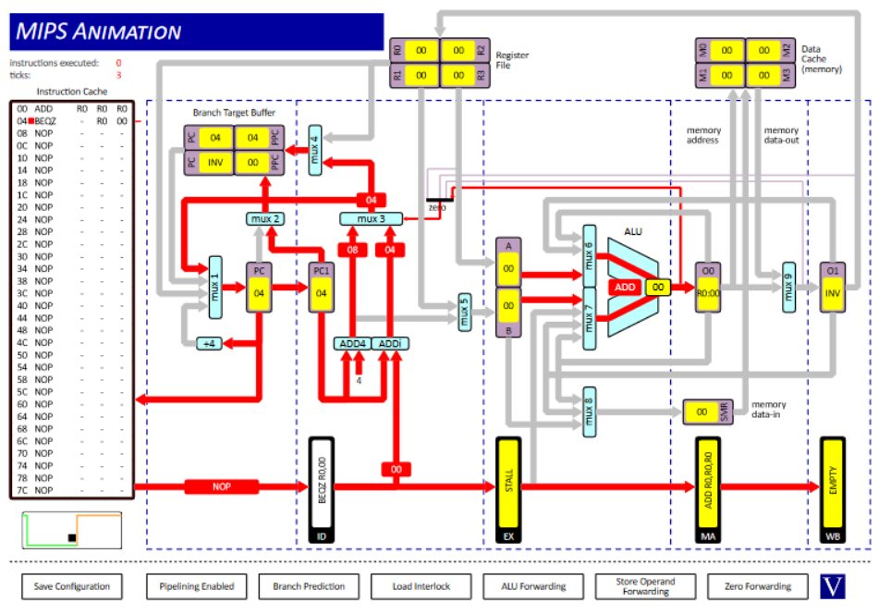

6

#### 7. RF to MUX1

ADD R0, R1, R0  
JALR R0, R1

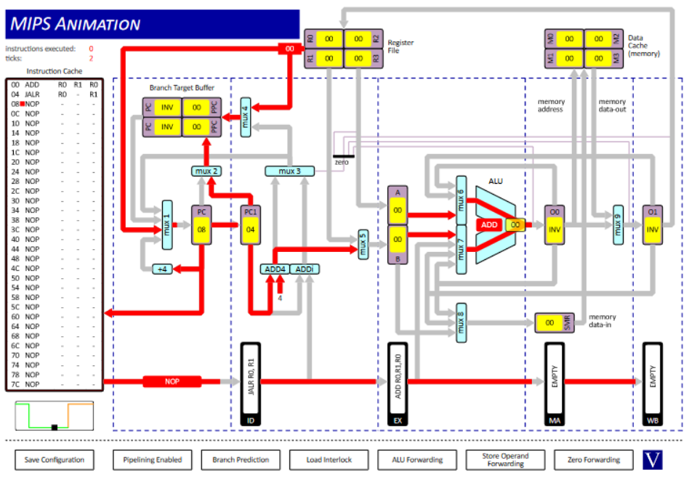

7

#### 8. BTB to MUX1

JAL R0, 0

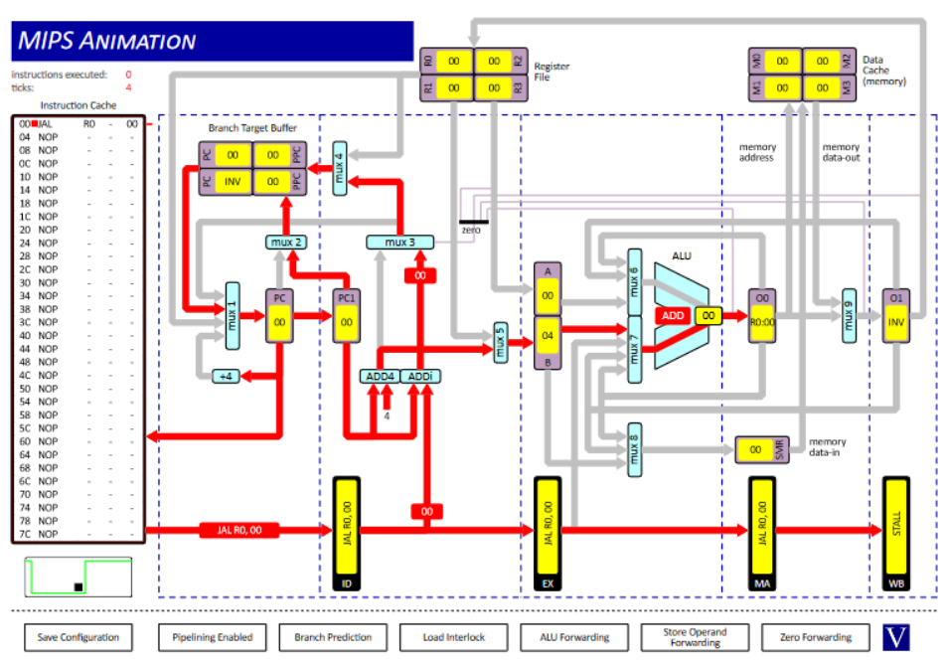

8

## Question 2

|  |  |  |  |
| --- | --- | --- | --- |
| Question | R1 Value | Clock Cycles | Explanation |
| (i) | 15 | 10 | Results in O0 and O1 can be fed back into the ALU without waiting for the values to be put in and gotten from the register file. |
| (ii) | 15 | 18 | Need to stall between instructions so that the registers can be updated as we don’t store results in O1 or O0. |
| (iii) | 6 | 10 | No stalls are used so values are accessed before the correct data has been put into the register file leading to the incorrect result. |

## Question 3

#### (i)

|  |  |
| --- | --- |
| Instructions | Clock Cycles |
| 38 | 50 |

The difference is due to stall cycles.

|  |  |
| --- | --- |
| Number of Cycles | Explanation |
| 4 | Due to the filling up of the pipeline at the start of the program. |
| 4 | Due to LD and SRLi both depending on R2 (see *(iii)*) - occurs 4 times. |
| 2 | Due to J as the processor needs to fetch the next instruction (BEQZ instead of ST) - occurs twice. |
| 2 | Due to branch prediction incorrectly loading the instruction following BEQZ - occurs twice. |

#### (ii)

|  |  |
| --- | --- |
| Instructions | Clock Cycles |
| 38 | 53 |

There are 3 more stall cycles than in *(i)*. These are due to there being no branch prediction for the unconditional jump instruction. The unconditional jump occurs 4 times but seeing as branch prediction makes a mistake at cycle 43 for the BEQZ instruction there is only an increase in 4 - 1 = 3 stall cycles.

#### (iii)

|  |  |
| --- | --- |
| Instructions | Clock Cycles |
| 38 | 46 |

Both LD and SRLi accessed R2 which meant that the processor needed to stall once after LD so that the register could be updated before it was accessed by SRLi. If we swap the two instructions we no longer access R2 twice in a row which removes the need to stall. This leads to a decrease of 4 in the number of clock cycles as these instructions are executed 4 times each.